DEDUCE Simulated Operating Characteristics of Phase 1 Dose Escalation Designs
Report Date and Time: “2021-05-20 16:20:31”
Software: DEDUCE app version 1.0 available here

Objective:
To evaluate the operating characteristics of the following dose escalation design(s): TARGET-CRM

Methods:
Trial operating characteristics are averaged over 100 simulated trials. Simulated trials have 5 dose levels labeled 1,2,3,4,5, starting on dose level 2, and assuming true toxicity probabilities of 0.05,0.12,0.2,0.25,0.4. The target toxicity probability is 0.2. One patient arrives every 30 days on average. The DLT observation period is 21 days.
For the TARGET-CRM and/or CRM design, the prior toxicity probabilities per dose level are 0.05,0.12,0.2,0.3,0.4. The cohort size is 2 and the maximum sample size is 20. Patients belong to one of two cohorts: Cohort A or Cohort B. Patients with pre-specified characteristics (e.g. tumor type, tumor mutation) belong to Cohort B; all other patients belong to Cohort A. The TARGET-CRM design allows enrollment of Cohort B patients at one dose level below the current dose during the DLT observation period of the current cohort of patients. The proportion of patients from Cohort B is 0.2. Simulated trials using the TARGET-CRM and/or CRM designs are required to have a minimum enrollment of 0 Cohort B patients.

Results:
Accuracy: For each dose level, Figure 1 presents the proportion of simulated trials that a given dose level was selected as the true MTD. The proportion of correct selection (PCS) of the MTD for the TARGET-CRM design is 0.32.
Safety: Figure 2 presents the proportion of patients experiencing a DLT for each dose level. The proportion of patients experiencing a DLT for the TARGET-CRM design is 0.18 which is lower than the target toxicity probability of 0.2
Patient Allocation: Figure 3 presents the proportion of patients assigned to each dose level. The proportion of patients assigned to the true MTD (dose level 3) for the TARGET-CRM design is 0.28.
Study Duration: Figure 4 presents the mean (+/- standard deviation) study duration in days for each design. The mean study duration for the TARGET-CRM design is 627.21 days (standard deviation = 24.59).
Table 1 presents a summary of the operating characteristics for each design.
Sample Size: The mean total sample size for the TARGET-CRM design is 20 (range = 20-20).

Figures:
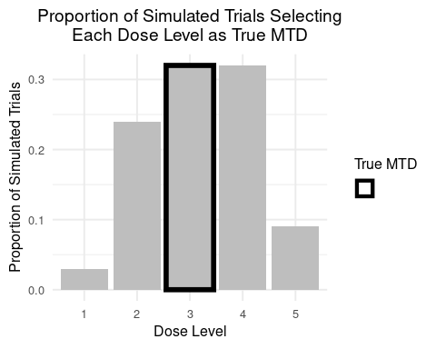
Figure 1: Proportion of simulated trials selecting each dose level as the true MTD.
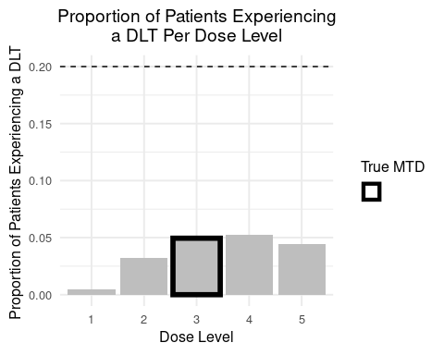
Figure 2: Proportion of patients experiencing a DLT per dose level. The target toxicity probability is denoted by the horizontal dashed line.
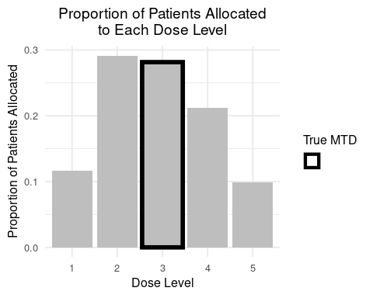
Figure 3: Proportion of simulated trials selecting each dose level as the true MTD.
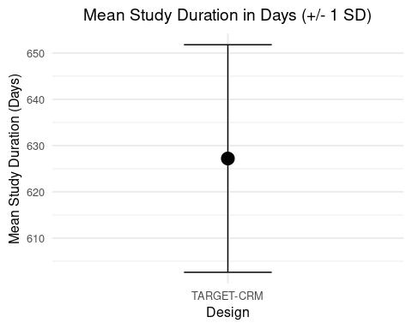
Figure 4: The mean (+/- 1 standard deviation) study duration in days.

Table 1: Summary of operating characteristics for the selected designs.
Operating Characteristic | TARGET-CRM
Proportion of correct selection (PCS) | 0.320
True MTD | 3.000
Proportion of trials selecting dose 1 as true MTD | 0.030
Proportion of trials selecting dose 2 as true MTD | 0.240
Proportion of trials selecting dose 3 as true MTD | 0.320
Proportion of trials selecting dose 4 as true MTD | 0.320
Proportion of trials selecting dose 5 as true MTD | 0.090
Proportion of patients experiencing a DLT overall | 0.184
Proportion of patients experiencing a DLT at dose 1 | 0.005
Proportion of patients experiencing a DLT at dose 2 | 0.032
Proportion of patients experiencing a DLT at dose 3 | 0.050
Proportion of patients experiencing a DLT at dose 4 | 0.052
Proportion of patients experiencing a DLT at dose 5 | 0.044
Mean total sample size | 20.000
Minimmum total sample size | 20.000
Maximum total sample size | 20.000
Proportion of patients enrolled at dose 1 | 0.116
Proportion of patients enrolled at dose 2 | 0.291
Proportion of patients enrolled at dose 3 | 0.281
Proportion of patients enrolled at dose 4 | 0.212
Proportion of patients enrolled at dose 5 | 0.098
Mean study duration in days | 627.207
Standard deviation of study duration in days | 24.594
Mean # of cohort B patients enrolled during DTL observation period (TARGET-CRM only) | 0.040
Standard deviation of # of cohort B patients enrolled during DLT observation period (TARGET-CRM only) | 0.197

